DBMS Practical Assignment 5

Title: Design at least 10 SQL queries for suitable database application using SQL DML

statements: all types of Join, Sub-Query and View.

-- Create Salesman table

CREATE TABLE Salesman (

salesman_id NUMBER PRIMARY KEY,

name VARCHAR2(50),

city VARCHAR2(50),

commission NUMBER

);

-- Create Customer table with a foreign key referencing Salesman

CREATE TABLE Customer (

customer_id NUMBER PRIMARY KEY,

cust_name VARCHAR2(50),

city VARCHAR2(50),

grade NUMBER,

salesman_id NUMBER,

CONSTRAINT fk_salesman FOREIGN KEY (salesman_id) REFERENCES Salesman(salesman_id)

);

-- Create Orders table with foreign keys referencing Customer and Salesman

CREATE TABLE Orders (

ord_no NUMBER PRIMARY KEY,

purch_amt NUMBER,

ord_date DATE,

customer_id NUMBER,

salesman_id NUMBER,

CONSTRAINT fk_customer FOREIGN KEY (customer_id) REFERENCES Customer(customer_id),

CONSTRAINT fk_salesman_order FOREIGN KEY (salesman_id) REFERENCES Salesman(salesman_id)

);

-- Insert data into Salesman table

INSERT INTO Salesman VALUES (5001, 'James Hoog', 'New York', 0.15);

INSERT INTO Salesman VALUES (5002, 'Nail Knite', 'Paris', 0.13);

INSERT INTO Salesman VALUES (5005, 'Pit Alex', 'London', 0.11);

INSERT INTO Salesman VALUES (5006, 'Mc Lyon', 'Paris', 0.14);

INSERT INTO Salesman VALUES (5007, 'Paul Adam', 'Rome', 0.13);

INSERT INTO Salesman VALUES (5003, 'Lauson Hen', 'San Jose', 0.12);

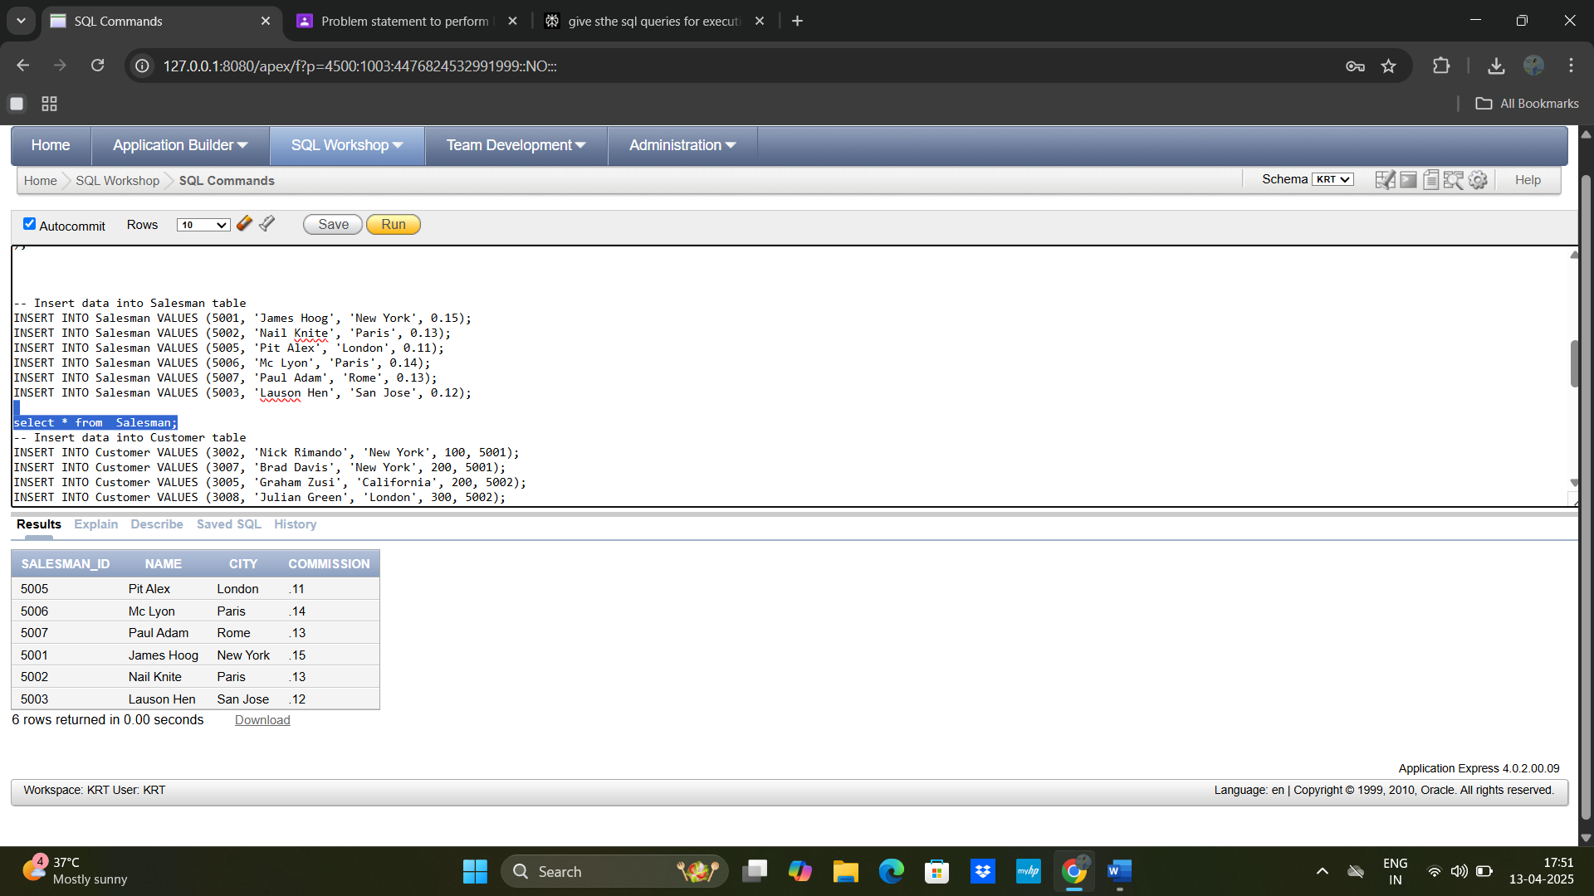

-- Insert data into Customer table

INSERT INTO Customer VALUES (3002, 'Nick Rimando', 'New York', 100, 5001);

INSERT INTO Customer VALUES (3007, 'Brad Davis', 'New York', 200, 5001);

INSERT INTO Customer VALUES (3005, 'Graham Zusi', 'California', 200, 5002);

INSERT INTO Customer VALUES (3008, 'Julian Green', 'London', 300, 5002);

INSERT INTO Customer VALUES (3004, 'Fabian Johnson', 'Paris', 300, 5006);

INSERT INTO Customer VALUES (3009, 'Geoff Cameron', 'Berlin', 100, 5003);

INSERT INTO Customer VALUES (3003, 'Jozy Altidor', 'Moscow', 200, 5007);

INSERT INTO Customer VALUES (3001, 'Brad Guzan', 'London', NULL, 5003);

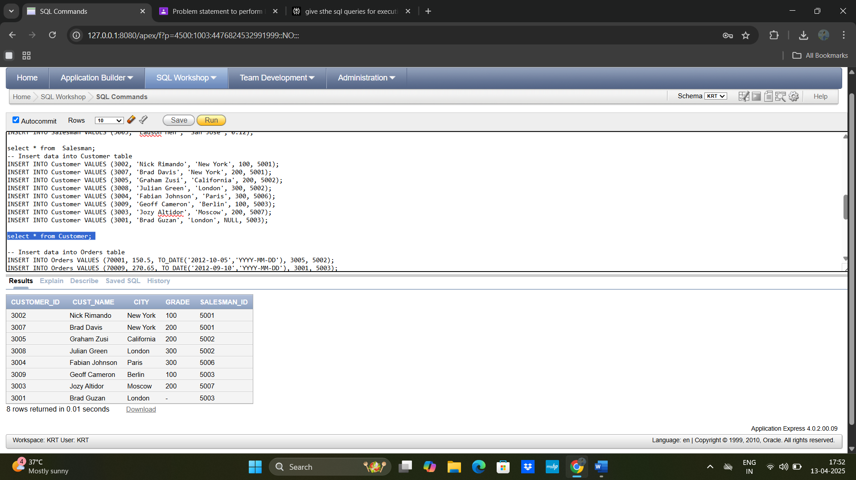

-- Insert data into Orders table

INSERT INTO Orders VALUES (70001, 150.5, TO_DATE('2012-10-05','YYYY-MM-DD'), 3005, 5002);

INSERT INTO Orders VALUES (70009, 270.65, TO_DATE('2012-09-10','YYYY-MM-DD'), 3001, 5003);

INSERT INTO Orders VALUES (70002, 65.26, TO_DATE('2012-10-05','YYYY-MM-DD'), 3002, 5001);

INSERT INTO Orders VALUES (70004, 110.5, TO_DATE('2012-08-17','YYYY-MM-DD'), 3009, 5003);

INSERT INTO Orders VALUES (70007, 948.5, TO_DATE('2012-09-10','YYYY-MM-DD'), 3005, 5002);

INSERT INTO Orders VALUES (70005, 2400.6, TO_DATE('2012-07-27','YYYY-MM-DD'), 3007, 5001);

INSERT INTO Orders VALUES (70008, 5760.0, TO_DATE('2012-09-10','YYYY-MM-DD'), 3002, 5001);

INSERT INTO Orders VALUES (70010, 1983.43, TO_DATE('2012-10-10','YYYY-MM-DD'), 3004, 5006);

INSERT INTO Orders VALUES (70003, 2480.4, TO_DATE('2012-10-10','YYYY-MM-DD'), 3009, 5003);

INSERT INTO Orders VALUES (70012, 250.45, TO_DATE('2012-06-27','YYYY-MM-DD'), 3008, 5002);

INSERT INTO Orders VALUES (70011, 75.29, TO_DATE('2012-08-17','YYYY-MM-DD'), 3003, 5007);

INSERT INTO Orders VALUES (70013, 3045.6, TO_DATE('2012-04-25','YYYY-MM-DD'), 3002, 5001);

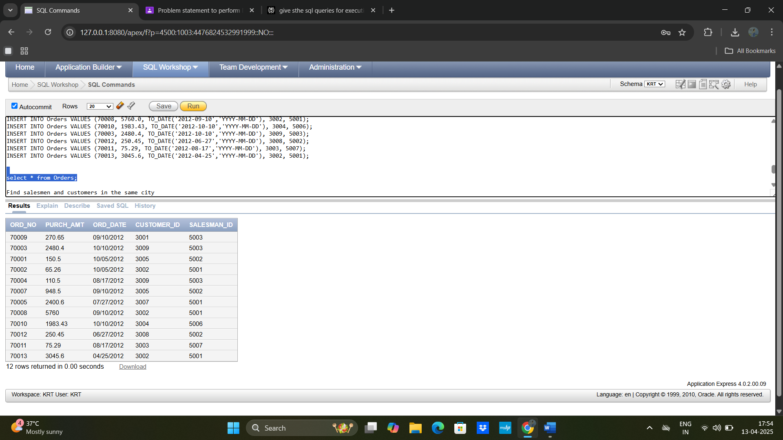

**1.Find salesmen and customers in the same city**

**SELECT** s.name **AS** salesman_name,

s.city **AS** salesman_city,

c.cust_name **AS** customer_name,

c.city **AS** customer_city

**FROM** Salesman s

**JOIN** Customer c **ON** s.city = c.city;

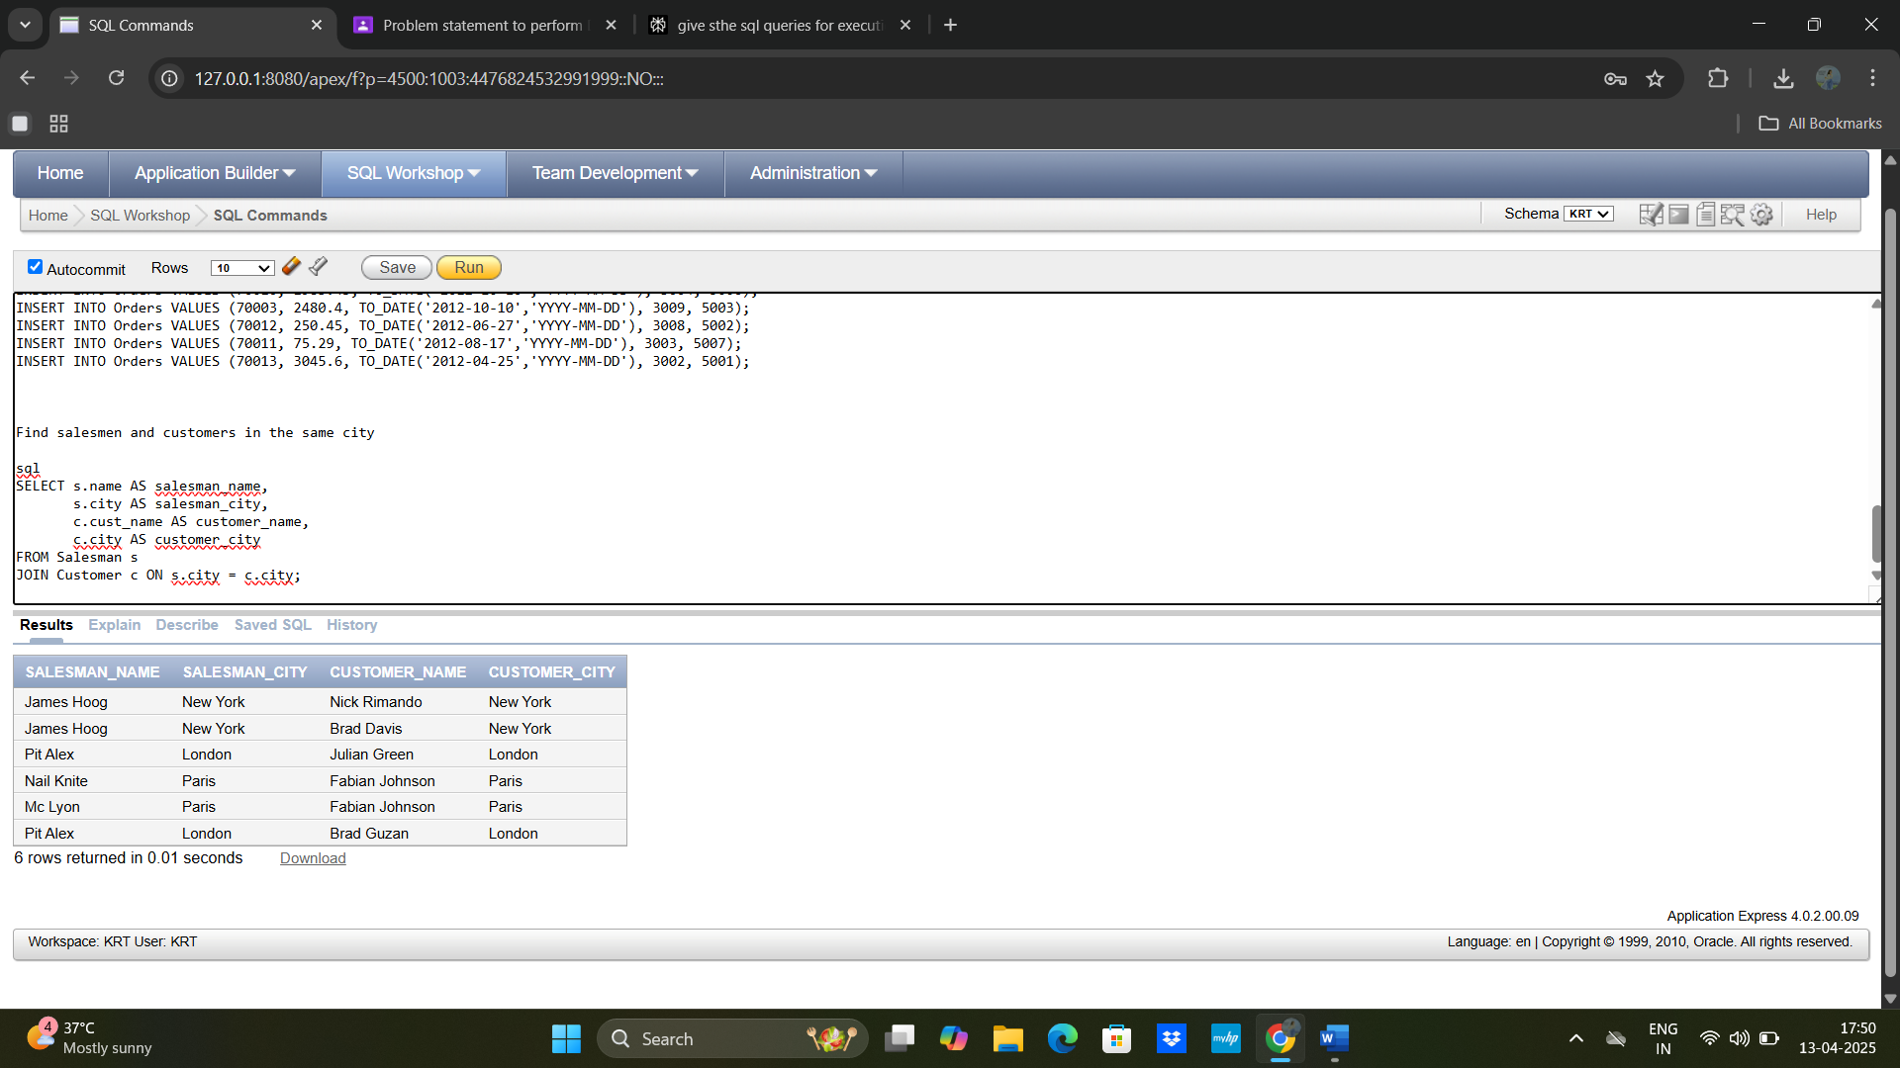

**2. List of salesmen working for customers with city and commission**

**SELECT** s.name **AS** salesman_name,

c.cust_name **AS** customer_name,

c.city **AS** customer_city,

s.commission

**FROM** Salesman s

**JOIN** Customer c **ON** s.salesman_id = c.salesman_id;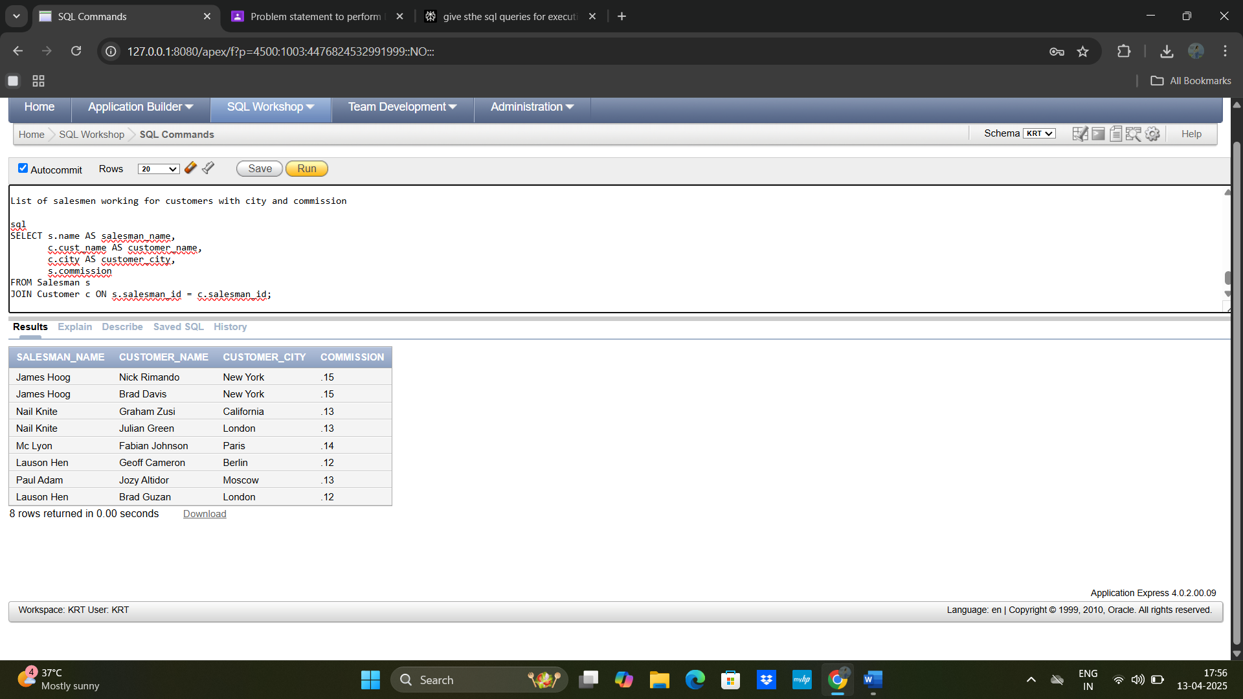

3) Join Salesman and Orders with relational rows

SELECT DISTINCT s.salesman_id,

s.name,

o.ord_no,

o.purch_amt

FROM Salesman s

JOIN Orders o ON s.salesman_id = o.salesman_id;

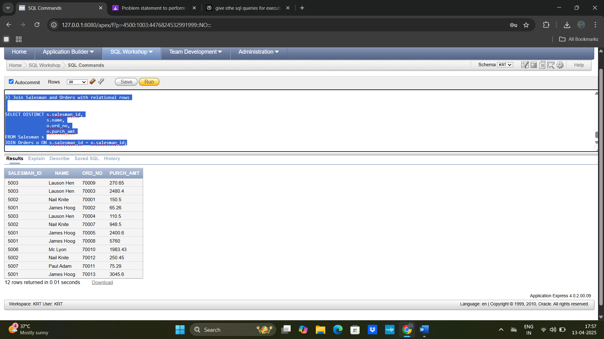

**4) List of salesmen working for one or more customers or not yet assigned**

**SELECT** s.name **AS** salesman_name,

COUNT(c.customer_id) **AS** number_of_customers

**FROM** Salesman s

**LEFT** **JOIN** Customer c **ON** s.salesman_id = c.salesman_id

**GROUP** **BY** s.name;

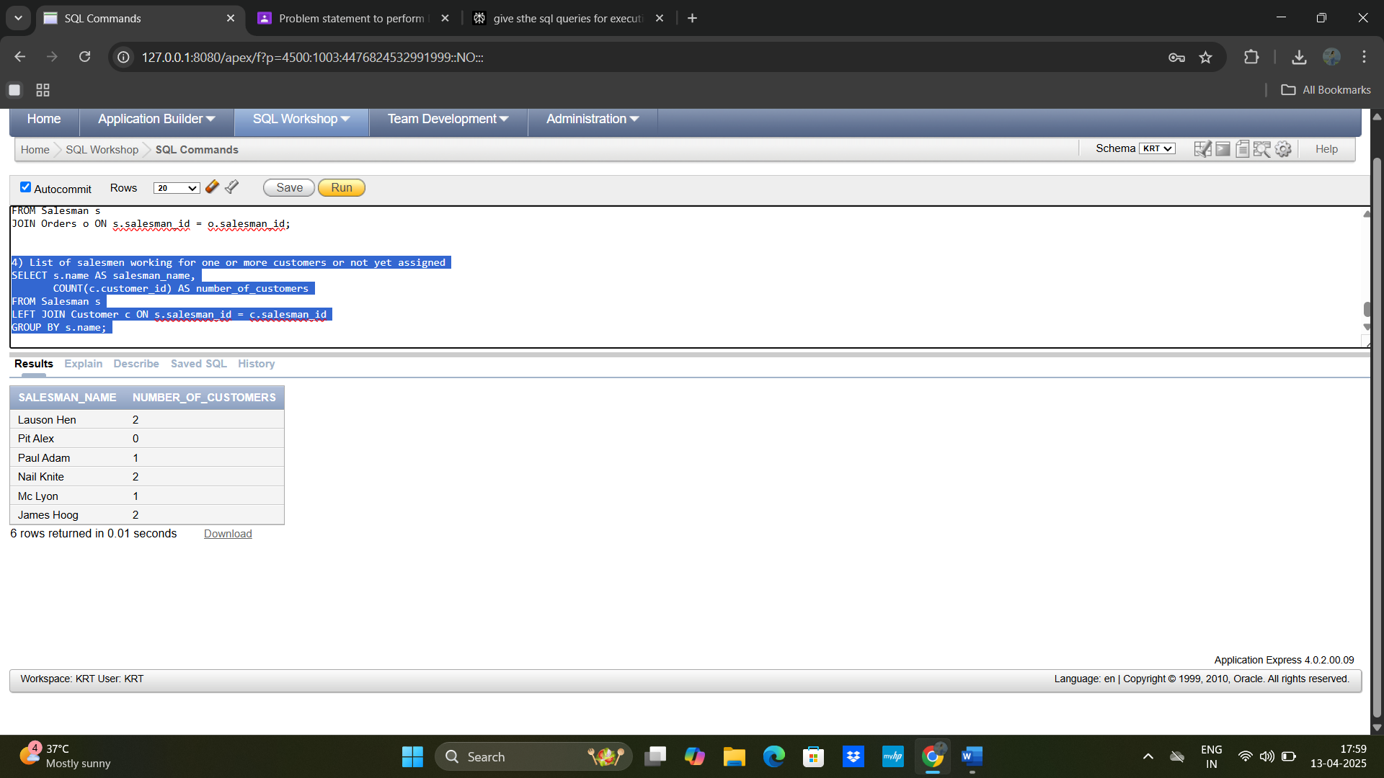

5) Ascending order list of salesmen based on customers

SELECT s.name AS salesman_name,

COUNT(c.customer_id) AS number_of_customers

FROM Salesman s

LEFT JOIN Customer c ON s.salesman_id = c.salesman_id

GROUP BY s.name

ORDER BY number_of_customers ASC;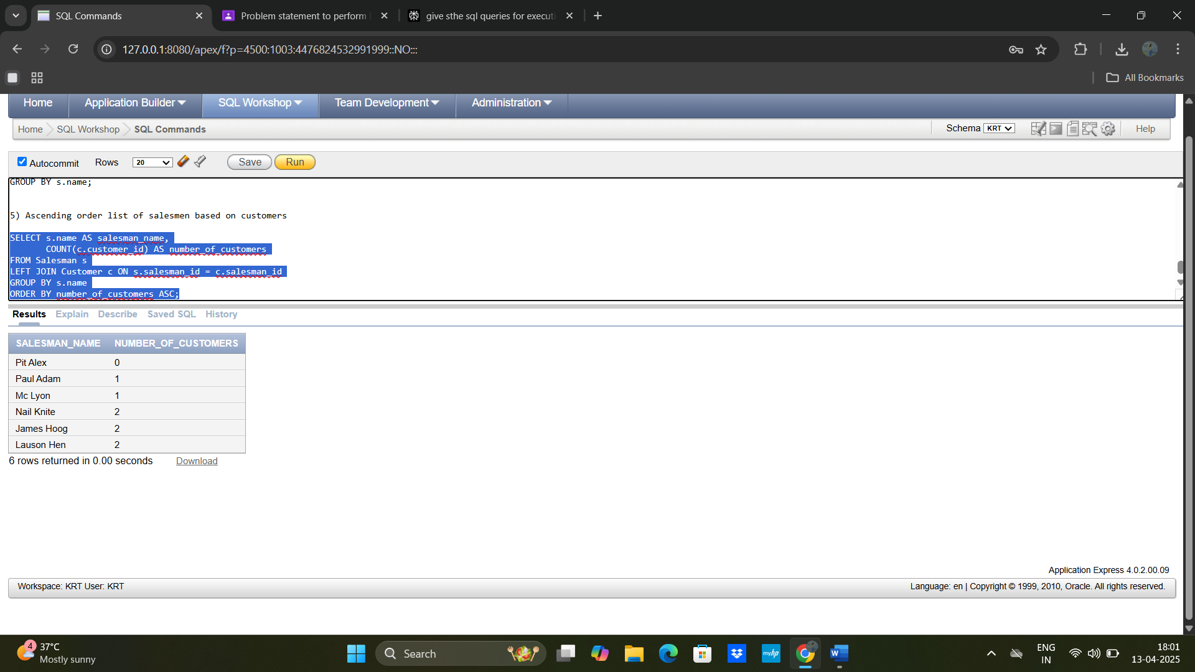

B)

**Employee Queries**

**Create Tables**

**CREATE** **TABLE** Employee (

employee_name VARCHAR2(50),

street VARCHAR2(50),

city VARCHAR2(50)

);

**CREATE** **TABLE** Works (

employee_name VARCHAR2(50),

company_name VARCHAR2(50),

salary NUMBER

);

**CREATE** **TABLE** Company (

company_name VARCHAR2(50),

city VARCHAR2(50)

);

**CREATE** **TABLE** Manages (

employee_name VARCHAR2(50),

manager_name VARCHAR2(50)

);

**Insert Data**

-- Insert data into Employee table

INSERT INTO Employee VALUES ('John Doe', '123 Main St', 'New York');

INSERT INTO Employee VALUES ('Jane Smith', '456 Elm St', 'Chicago');

INSERT INTO Employee VALUES ('Mike Brown', '789 Oak St', 'Los Angeles');

INSERT INTO Employee VALUES ('Emily Davis', '901 Maple St', 'Houston');

INSERT INTO Employee VALUES ('David Lee', '234 Pine St', 'Seattle');

select * from Employee;  
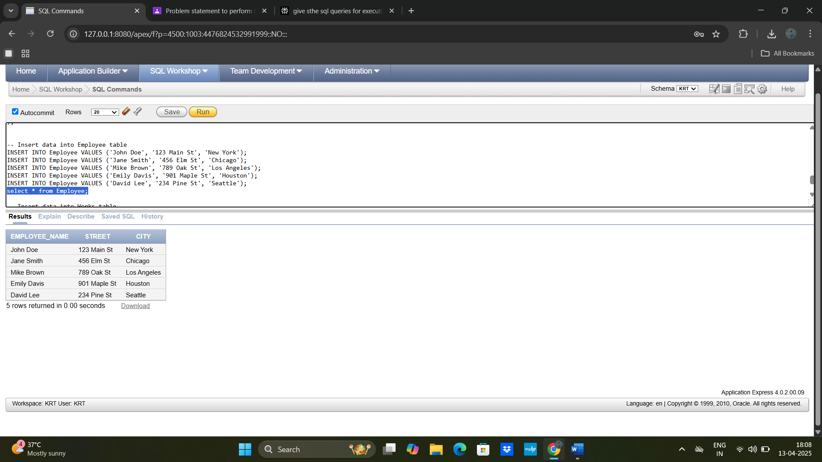

**-- Insert data into Works table**

**INSERT INTO Works VALUES ('John Doe', 'Tata', 15000);**

**INSERT INTO Works VALUES ('Jane Smith', 'Reliance', 8000);**

**INSERT INTO Works VALUES ('Mike Brown', 'First Bank Corporation', 12000);**

**INSERT INTO Works VALUES ('Emily Davis', 'Tata', 18000);**

**INSERT INTO Works VALUES ('David Lee', 'Reliance', 9000);**

**select * from Works;**

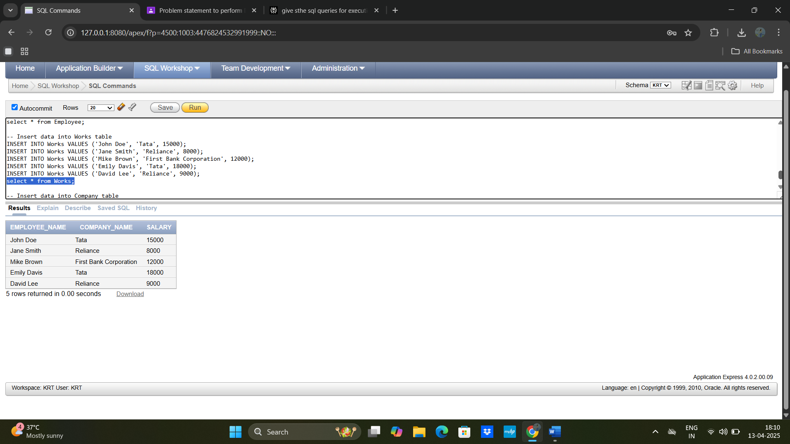

-- Insert data into Company table

INSERT INTO Company VALUES ('Tata', 'Mumbai');

INSERT INTO Company VALUES ('Reliance', 'Mumbai');

INSERT INTO Company VALUES ('First Bank Corporation', 'New York');

select * from Company;

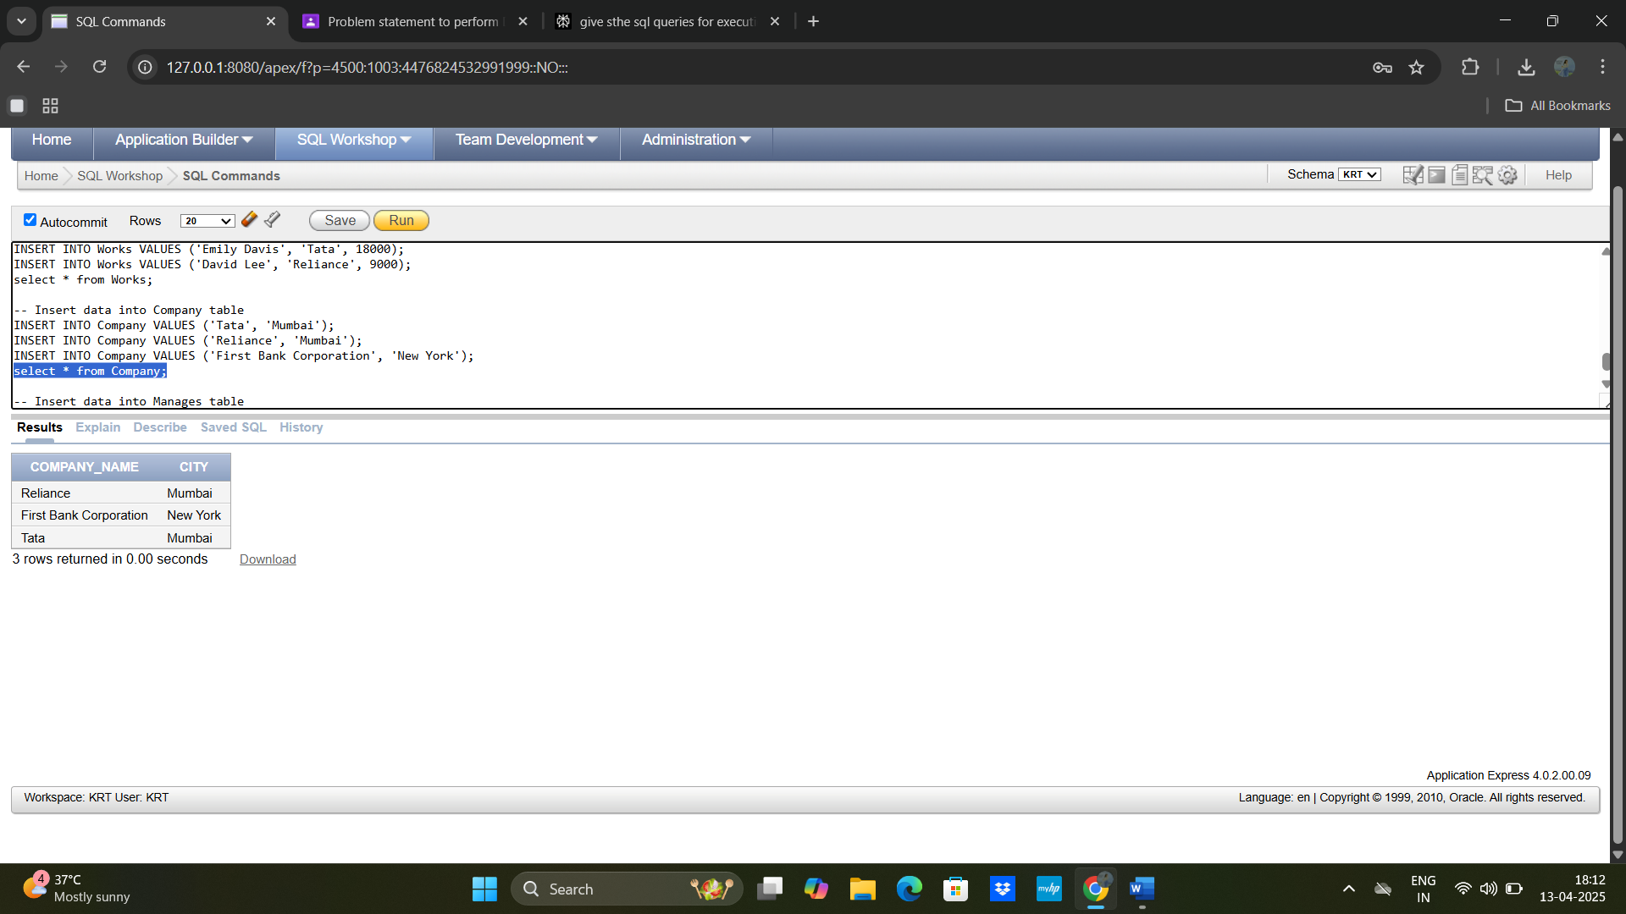

-- Insert data into Manages table

INSERT INTO Manages VALUES ('John Doe', 'Jane Smith');

INSERT INTO Manages VALUES ('Mike Brown', 'David Lee');

select * from Manages;

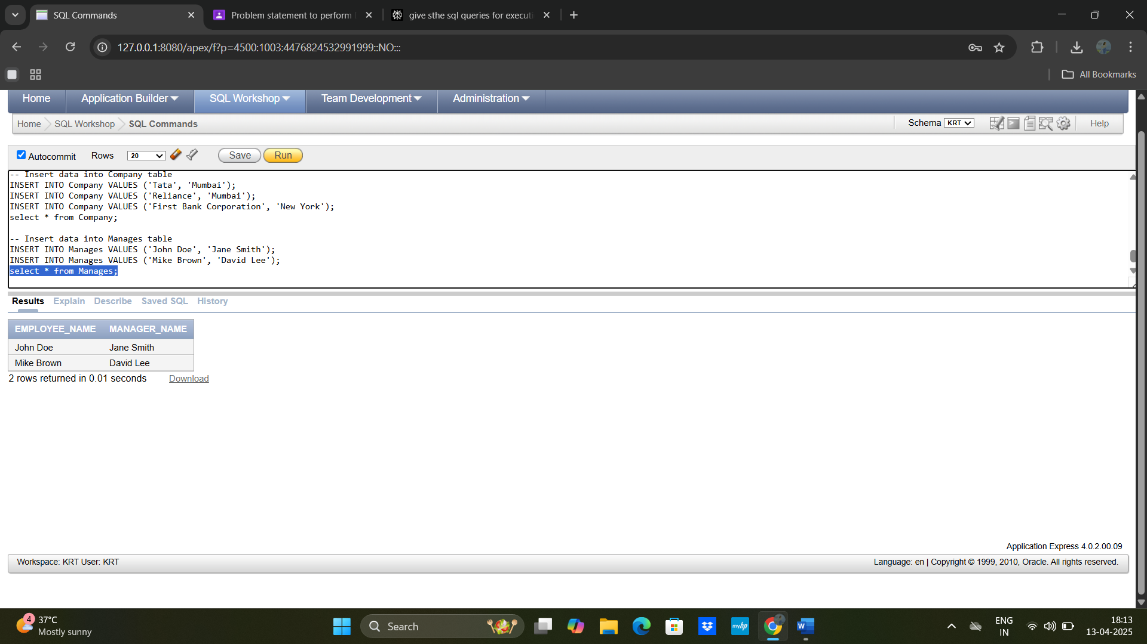

**Q1)** Employees working for Tata earning more than $10k:

**SELECT** e.employee_name,

e.street,

e.city

**FROM** Employee e

**JOIN** Works w **ON** e.employee_name = w.employee_name

**WHERE** w.company_name = 'Tata' AND w.salary > 10000;

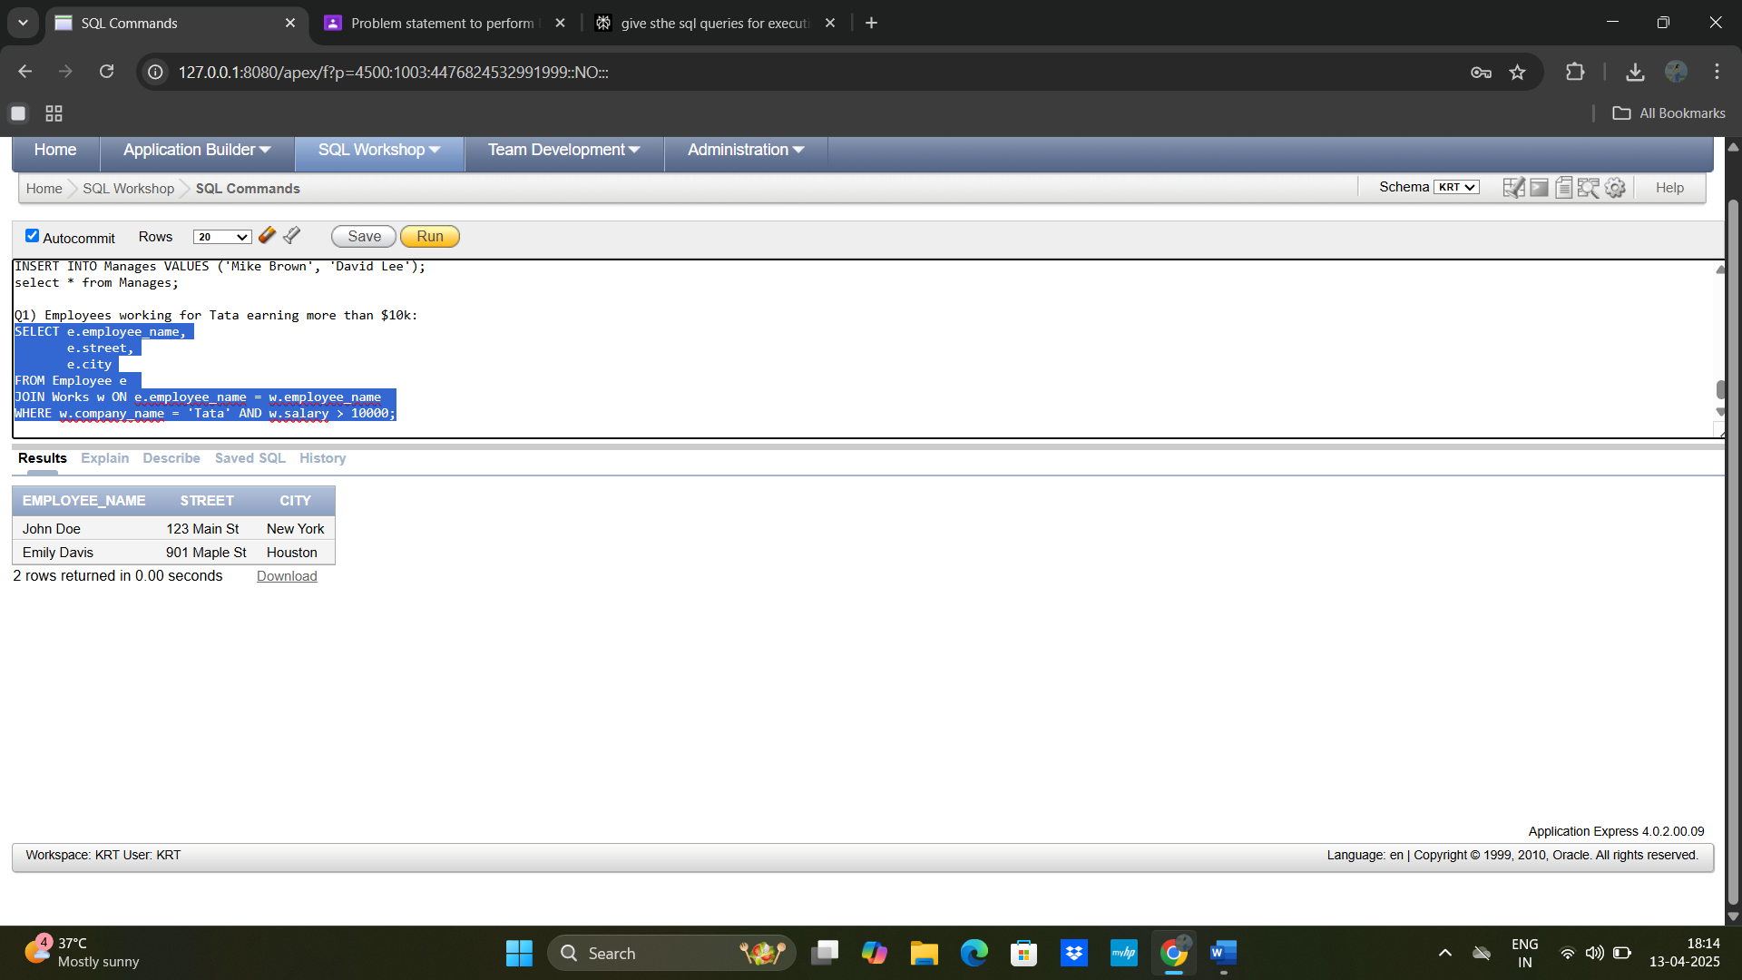

**Q2)** Employees not working for Tata:

sql

**SELECT** e.employee_name

**FROM** Employee e

**WHERE** NOT **EXISTS** (

**SELECT** * **FROM** Works w

**WHERE** w.employee_name = e.employee_name AND w.company_name = 'Tata');

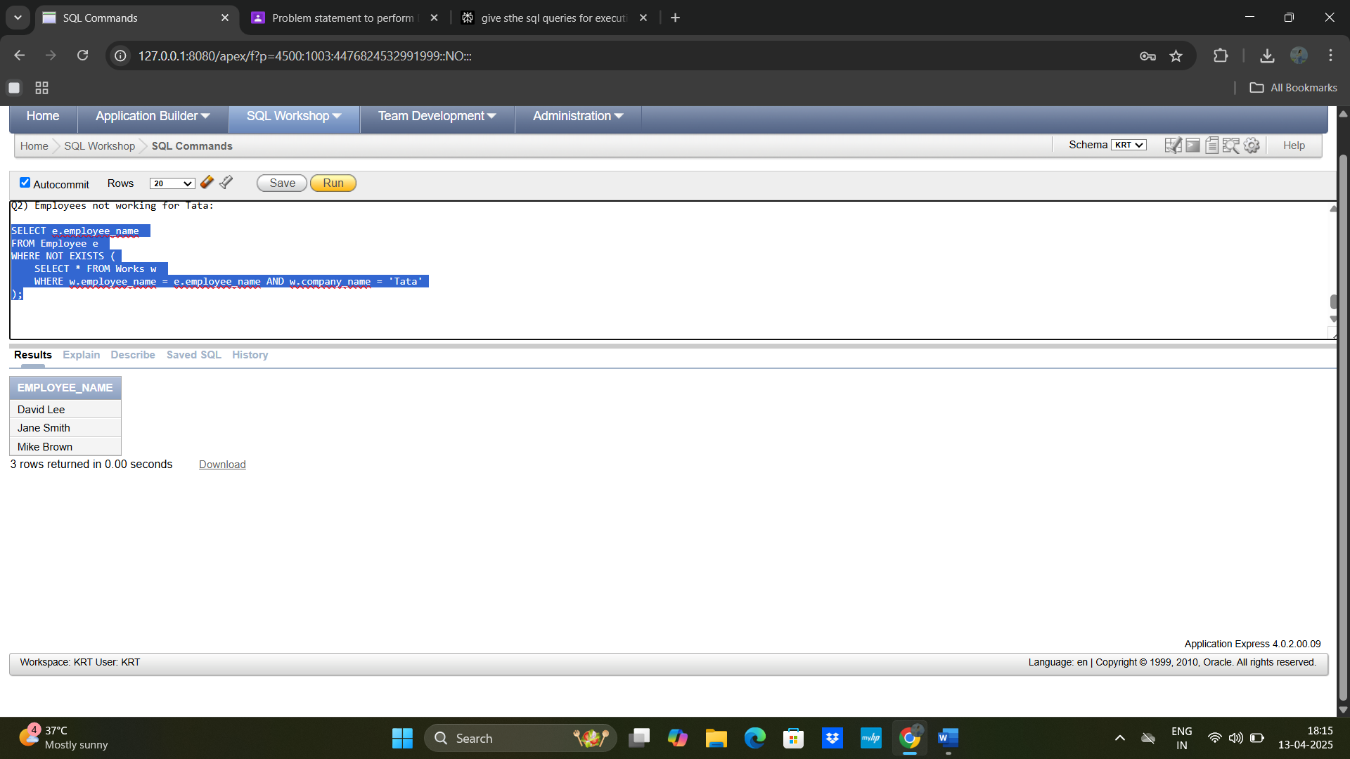

**Q3)** Employees earning more than every Reliance employee:

sql

**SELECT** w.employee_name

**FROM** Works w

**WHERE** w.salary > **ALL** (

**SELECT** salary **FROM** Works **WHERE** company_name = 'Reliance'

);

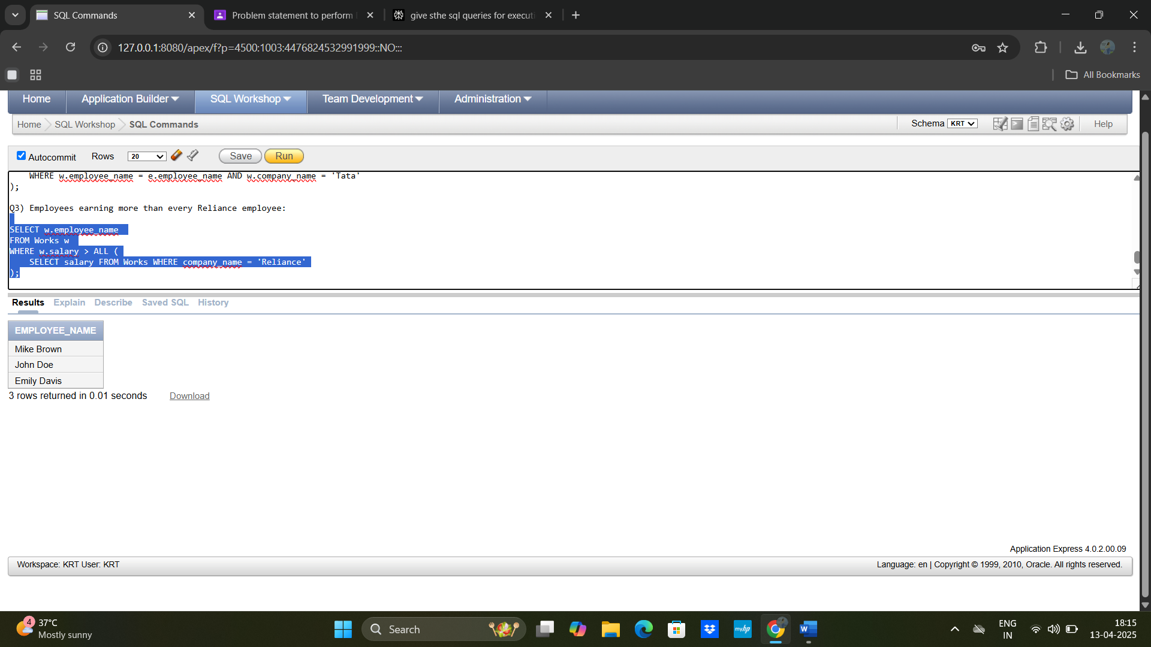

**Q4)** Company with the smallest payroll:

SELECT company_name

FROM Works

GROUP BY company_name

HAVING SUM(salary) = (

SELECT MIN(SUM(salary))

FROM Works

GROUP BY company_name

);

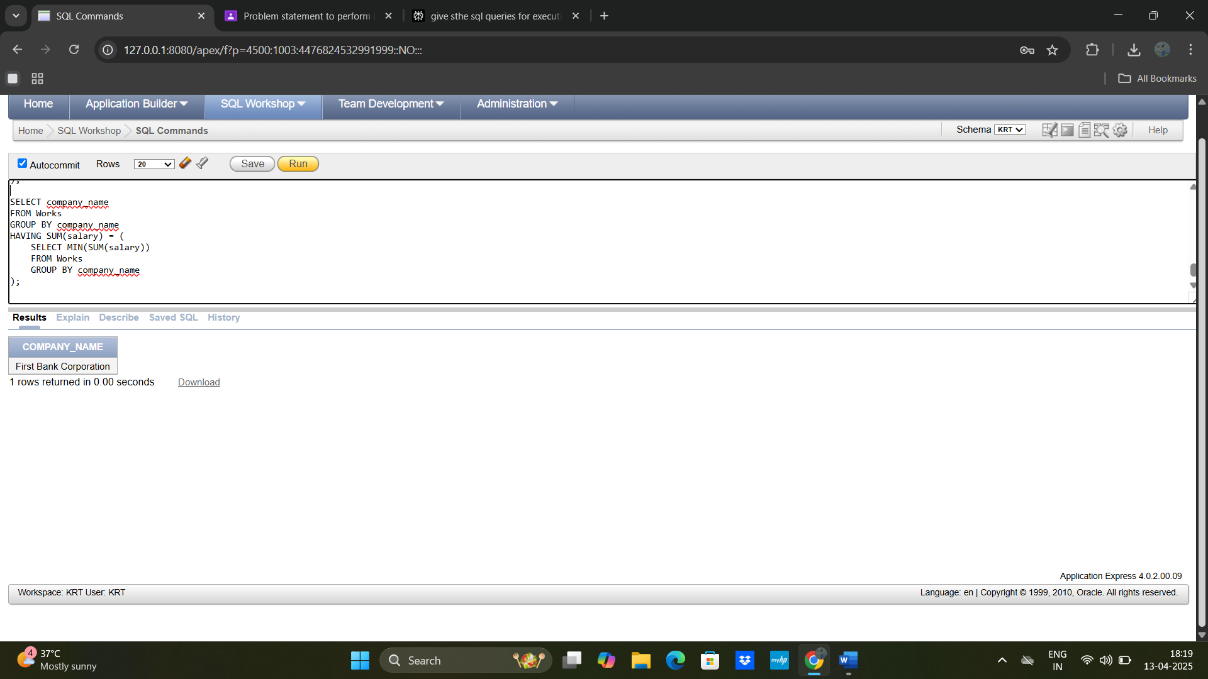**Q5)** View for employees working for First Bank Corporation:

CREATE VIEW FirstBankEmployees AS

SELECT e.employee_name,

e.city

FROM Employee e

JOIN Works w ON e.employee_name = w.employee_name

WHERE w.company_name = 'First Bank Corporation';

SELECT * FROM FirstBankEmployees;